MGMT640 - Financial Decision Making for Managers
MGMT 640 Lecture 10 : Cost Allocation and Activity-Based Costing
LEARNING OBJECTIVES
1. Explain why indirect costs are allocated.
2. Describe the cost allocation process.
3. Discuss allocation of service department costs.
4. Identify potential problems with cost allocation.
5. Discuss activity-based costing (ABC) and cost drivers.
6. Distinguish activity-based costing (ABC) from activity-based management (ABM).
7. Understand the four-steps involved in an ABM study

REVIEW
This session covers the many aspects and techniques of cost allocation. The basic reasons for cost allocation are introduced, followed by an overview of the cost allocation process. This latter topic is then expanded to include service department cost allocation and activity-based costing (ABC). The final topic presented is activity-based management (ABM).

Purposes of Cost Allocation
- (L.O.1) The allocation of a resource's cost to any segment is, in effect, a charge for the use of that resource. From a decision-making standpoint, the allocated cost should measure the opportunity cost (what is given up in order to get something else) of using the resource. However, this is difficult to operationalize because the opportunity cost may quickly change.

- A second reason for allocation is to reduce frivolous use of a common resource. If there is no cost for the use of a resource it may be used for frivolous or nonessential purposes. Even frivolous use may have opportunity costs associated with it. For example, if the computer is being used to play games, it cannot be used for essential work.
- A third reason for allocation is to encourage evaluation of the services provided by the common resource. Again, if there is no charge for services, there is no incentive to evaluate whether or not the services are needed or their true cost.
- A final reason for cost allocation is to comply with GAAP's requirement of full costing for external reporting purposes.
- Another possibility is when "cost-plus" contracts are being used, such as with government contractors.

    - Cost in these contracts often includes not only direct and indirect production costs, but also a share of the general and administrative costs.

    - A major problem with such allocation is that it motivates management to allocate as much cost as possible to goods produced on a cost-plus basis.

Process of allocation
- (L.O.2) The first step in cost allocation is the determination of the cost object, i.e., the product, service, or department that is to receive the allocation.

- The second step is to form cost pools. These are groupings of costs whose total is to be allocated using an allocation base.
    - Cost pools may be formed along departmental lines or by major activity, e.g., set ups.
    - An overriding concern in forming a cost pool is to ensure that the costs included are similar or homogeneous.
    - The number of cost pools will depend on a company's need for accurate information and a cost-benefit analysis for such information.

- The third step in the allocation process is selecting a base that has a cause-and-effect relationship with the costs to be allocated. Many of these bases are volume related, such as direct labor hours or machine hours.
    - A problem with such bases is that while they may be equally valid, they may result in substantially different costs being assigned to the cost objects.
    - If the costs to be allocated are fixed, no cause-and-effect relationship need be established. Other criteria are used:
            - Relative benefits. The allocation base should result in more costs being allocated to the cost objectives that benefit most from incurring the cost.
            - Ability to bear. The allocation base should result in more costs being allocated to the cost objectives that are more profitable.
            - Equity. The allocation base should result in allocations that are perceived as fair or equitable.

- Traditional cost systems assign all overhead to one cost pool. Common activity drivers are units produced, direct labor hours, direct labor cost, and machine hours.

Allocating Service Department Costs
- (L.O.3) Cost pools are often formed by service departments, and these costs are allocated to production departments (the cost objectives).
    - The direct method allocates service department costs directly to the production departments, not to any other service departments.

- This method ignores any reciprocity of services between service departments.
    - Budgeted costs rather than actual costs should be allocated. This prevents the service departments from passing their cost inefficiencies on to the producing departments.

Problems with Cost Allocation
- (L.O.4) A number of problems may occur when indirect costs are allocated.
    - Performance evaluation should be based on those revenues and costs that a manager has the ability to influence or control.

- This is referred to as a responsibility accounting system.
    - Under a responsibility accounting system, cost allocation may be required when one department is responsible for the costs incurred in another department. For example, the production department is responsible for the costs incurred by the machine repair department.

- Care must be taken to only allocate those costs over which a manager has some control (controllable costs).

- If noncontrollable costs appear on a manger's performance report, they should be clearly labeled as such, and not be part of the manager's evaluation.
    - The allocation of indirect costs is quite often arbitrary. This results in managers feeling that their departments receive unjustified allocations.
    - One of the biggest problems with the allocation process occurs when the allocation makes a fixed cost appear to behave as if it were a variable cost. This occurs when fixed costs are unitized. The result may be poor decision-making.

- Another problem with unitizing fixed costs is that the amount allocated to any one department depends, in part, on what the other departments do.

- To remedy this problem, fixed cost allocations should be made in lump-sum amounts based on the long-run needs of the user departments. These allocations will generally remain the same year after year.

    - Another problem occurs when only one or two cost pools are used to allocate overhead costs. While this may greatly simplify product cost determination, it may also seriously distort it. In general, the more overhead cost pools used, the more accurate the product costs. However, there is a cost-benefit trade off.

    - The final problem with cost allocations occurs when the only bases used are measures of production volume, e.g., direct labor hours or machine hours. The problem is, that not all overhead costs vary with volume. The solution may be activity-based costing.

Activity-Based Costing (ABC)
Activity-based costing rests on the premise that products and services consume resources. Managers are expected to know the activities that are required for making products or providing a service. Additionally, managers must be aware of the cost related to these activities. Under ABC, the cost of a product is determined by the product’s “use” of the various activities in the manufacturing process.
- Traditional costing allocates costs based solely on one activity – usually volume or labor hours. Only one predetermined overhead rate is normally used in traditional costing. That rate is determined by estimating the total annual overhead cost and dividing by estimated annual activity.

- (L.O.5) Activity-based costing (ABC) first assigns costs to activities in the production process, then to the individual products or services, based on each cost object’s USE of the activities. By focusing attention on the activities in the production process, ABC helps to identify steps in the process that management may need to make more efficient, or to change. ABC recognizes that the demand for overhead activities is driven by various cost pools with several activity cost drivers. In other words, because products typically move through multiple steps in a production process, multiple cost drivers will ultimately impact the total allocated cost of a product.

- In the ABC approach, companies identify the major activities that cause overhead costs to be incurred. The cost of the resources consumed by these activities are grouped into cost pools. Measures of activity (cost drivers) are then identified and used to develop rates, which are, in turn, used to allocate overhead costs to the products that use them.

    - This is an improvement over the traditional approach to overhead allocation that allocates overhead costs in proportion to production volume.
    - The traditional approach usually results in overcosting high-volume products and undercosting low-volume products.

- The reason is that all overhead costs are not proportional to volume (set-up costs, inspection costs, etc.)
    - Under ABC each activity cost pool has its own rate. Products are assigned costs for only those activities that they use.

- There are five steps to allocate costs using ABC:
  - Identify the activities in the production process that consume resources. These are the cost pools.
  - Assign total costs to these activities (or cost pools).
  - Identify the cost drivers associated with each activity.
  - Compute a rate per cost driver unit for each cost driver.
  - Assign costs to the cost object using all applicable cost drivers.

- ABC, like any other system, has both benefits and limitations.
    - Benefits of ABC
      - It is less likely to overcost simple, high-volume products and undercost complex, low-volume products.
      - It may lead to better cost control. With a number of activities identified, instead of a single overhead cost pool, it is easier to see where cost improvements are needed.

    - Limitations of ABC
      - Its major disadvantage is its expense. It is more costly to develop 10 cost pools and assign costs from them than a single pool.
      - In practice it is used to develop the "full cost" of a product. Which means that fixed costs are included in the allocations. This makes it difficult to determine the incremental cost of producing an item. So, it is not conducive to good decision-making.

Activity- Based Management (ABM) versus Activity-Based Costing (ABC

- (L.O.6) ABM is a management tool that involves analyzing and costing activities with the goal of improving efficiency and effectiveness, ABM focuses on activities with the intent of managing the activities themselves.
              - For example, ABM would focus on ways to improve the setup process and ways to eliminate the demand for setup activity.

              - You need to know the cost of activities before you can do a good job managing them.

              - A warning is needed however. Great care should be taken in selecting any allocation base because it may affect management behavior and decision-making in ways that are not obvious

- Activity-based management is related to the value chain. Remember, a value chain is a linked set of value-creating activities starting with raw materials and leading to the ultimate end use of the goods or services provided. Activity analysis is a fundamental aspect of activity-based management.

- Activity analysis is a systematic approach for organizations to evaluate the processes they use to produce products for their customers. It can be used to identify and eliminate activities that add costs but not value to the product or service.

- Once activities have been identified with activity analysis, costs can be determined for those activities, and the steps for activity-based costing can begin.

(Appendix) Conducting an Activity-Based Management Study

- (L.O. A1) The goal of an ABM study is to improve a business process, e.g., shipping goods to stores or checking guests into a hotel.

  - A typical ABM study consists of four steps:
              - Step 1: Determine the major activities involved in the process under study. This is done through interviews and observation.

              - Step 2: Identify the resources used by each activity. This is accomplished by reviewing source documentation and accounting records.

              - Step 3: Evaluate the performance of the activities by comparison to similar activities performed in other companies.

              - Step 4: Identify ways to improve the efficiency and/or effectiveness of the activities. This is done by brainstorming ideas, asking for input from company managers, or thinking about successful practices in other companies.

THE USE OF COST INFORMATION IN MANAGEMENT DECISION MAKING

LEARNING OBJECTIVES

- Explain the role of incremental analysis in management decisions.
Define sunk cost, avoidable cost, and opportunity cost and understand how to use
these concepts in analyzing decisions.
- Analyze decisions involving joint costs.

- Discuss the importance of qualitative considerations in management decisions.
- Understand the five-step approach to the Theory of Constraints.

REVIEW
This session addresses short-term decision making using incremental analysis and the qualitative aspects of decision making. Topics include additional processing, make-or-buy, dropping product lines, and joint product decisions. The appendix demonstrates the five-step approach to the Theory of Constraints.

Incremental Analysis
- (L.O.1) Decision-making involves choosing between alternatives. The revenues and costs that differ between alternatives are the basis for decision-making. These are call incremental (or differential) revenues and costs.

    - Relevant revenues and costs are the incremental (or differential) revenues and costs.

- Additional processing decisions involve determining whether to sell a product that is partially completed or process it further and then sell it. The decision is based on the difference between the incremental revenues and the incremental costs.
- The incremental revenues represent the difference between the revenues generated from selling the product as it is and the revenues generated after further processing.

- The incremental costs are the costs incurred from further processing. The costs already incurred are sunk costs and are therefore irrelevant.

- If incremental revenues exceed the incremental costs, the product should be processed further.

- If incremental revenues are less than incremental costs, the product should be sold as is

- If incremental revenues equal incremental costs, qualitative characteristics must be used to make the appropriate decision.
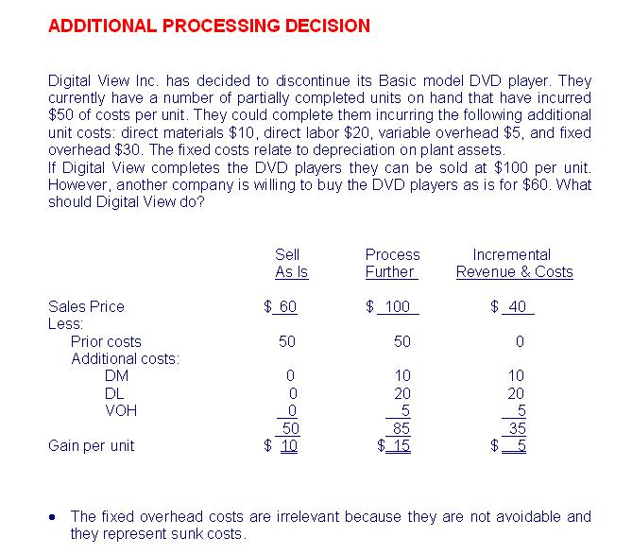

- Make-or-buy decisions are concerned with deciding whether to produce an item in-house or purchase it from an outside supplier. The decision is based on comparing the cost of purchasing the item to the incremental cost of making the item. The incremental costs include:
    - Variable costs of production.
    - The avoidable fixed costs, i.e., the fixed costs that won't be incurred if the item is purchased.
    - Any opportunity cost that may occur if the space freed by not producing the item could be used to generate a benefit, e.g., a cost savings or incremental margin.
    - There are often long-term considerations related to a make-or-buy decision. For example, if the company decides to buy instead of make, what are the long-term consequences if the supplier shuts down or cannot supply enough?
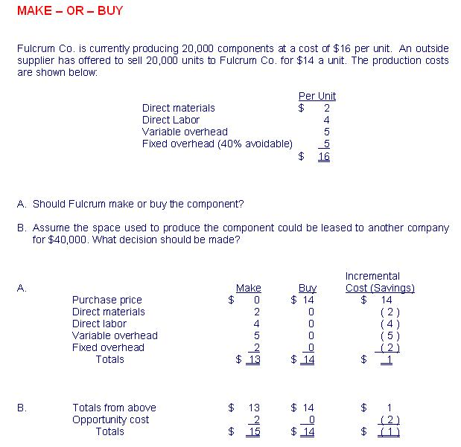

- Dropping a product line decisions involve deciding whether or not to continue a product line or segment. The decision is based on whether or not the product's revenue exceeds the costs directly traceable to the product, including any direct fixed costs. Common fixed costs are costs incurred jointly by several product lines, these are irrelevant costs. The relevant items would include:

  - The product's revenue.
  - The product's variable costs.
  - The product's direct fixed costs.
  - There are qualitative considerations as well as long-term consequences related to dropping a product line.
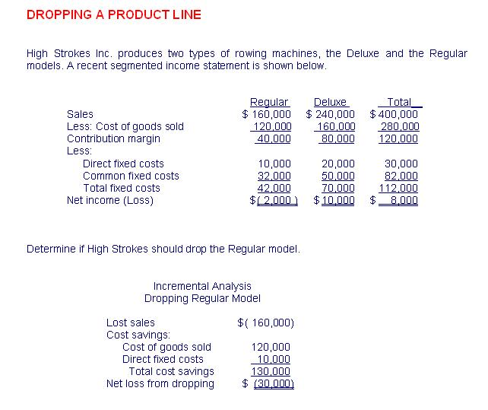

Summary of Incremental, Avoidable, Sunk, and Opportunity Costs
- (L.O.2) The basic approach to decision making is to compare the incremental revenues and incremental costs between decision alternatives. Some of the terms used in such analyses include:

    - Incremental costs (also referred to as avoidable costs) are relevant to decision-making as they are costs that differ between alternatives.
    - Sunk costs are costs that have already been incurred and are not reversible. They are irrelevant to decision making.
    - Opportunity costs are benefits foregone from not selecting a particular alternative. They are relevant to decision making.

Decisions Involving Joint Costs
- (L.O.3) Joint products occur when two or more products are produced from a common set of inputs, referred to as joint costs. The stage at which the products are individually identifiable is called thesplit-off point. There are two different types of decisions to make concerning joint products and joint costs.

  - Allocation of joint costs is necessary to determine the carrying value of the joint products in inventory. Two methods of allocating joint costs are:

    - Using physical quantities of output. Each joint product receives an allocation of the joint costs based on their relative amount of output units in relation to total output.

    - Using relative sales values at the split-off point. Each product receives an allocation of joint costs based on their relative sales value at the split-off point in relation to total sales at the split-off point. This is the more desirable of the two methods.

  - Joint costs are ignored as irrelevant (or sunk) costs in deciding whether to sell the joint products at the split-off point or processing them further and then sell them
    - The decision is based on comparing the incremental revenues (revenues after further processing minus revenues at split-off point) to incremental costs (costs incurred beyond the split-off point).
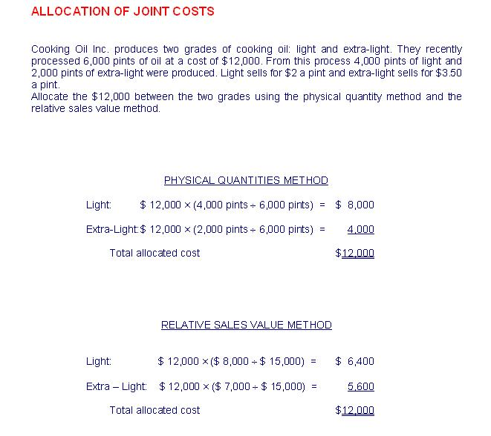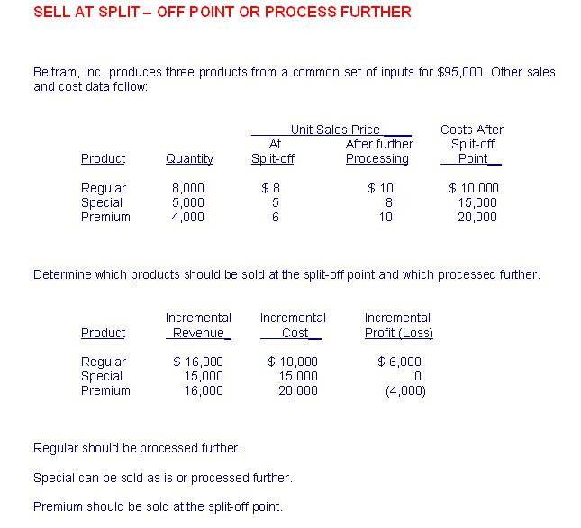

Qualitative Consideration in Decision Analysis
- (L.O.4) Quantitative analysis involves the revenues and costs connected with a decision. Another facet of the decision is the qualitative factors. Sometimes these factors outweigh the quantitative ones. For example, closing down a product line may be warranted quantitatively, but the effect on employee morale, a qualitatively factor, may outweigh the numerically correct decision.

(Appendix) The Theory of Constraints (TOC)
- L.O.A1) Decisions related to eliminating constraints can lead to large increases in profit

- The five step process of dealing with constraints are:
- Step 1: Identify the binding constraint, i.e., the process that limits throughput.

- Step 2: Optimize the use of the constraint, i.e., produce the products with the highest contribution margin per unit of the constraint.

- Step 3: Subordinate everything else to the constraint, i.e., focus attention on loosening the constraint, not on improving other departments.

- Step 4: Break the constraint, which can include:
- Cross-train workers
- Outsource some of the work
- Purchase additional equipment
- Hire additional workers
- Train workers to be more efficient

- Step 5: Identify a new binding constraint. If all departments have excess capacity, then focus on building demand.
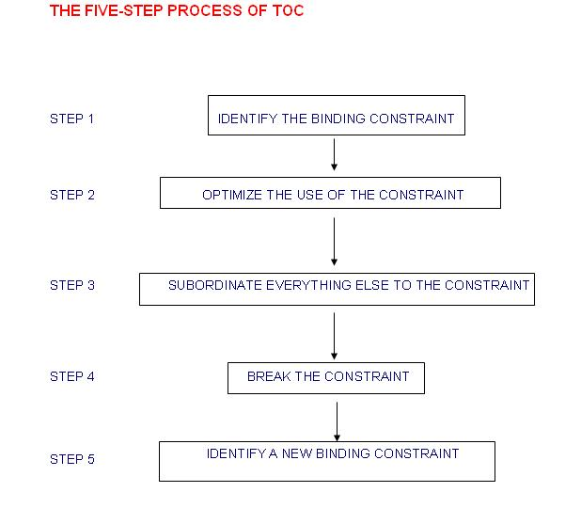

- Implications of TOC
  - Inspections should take place before work is transferred to the constrained department.
  - Batch sizes should not be reduced, so valuable time is not wasted on numerous set-ups.
  - Across the board cuts should not be considered. Cuts in the constrained department could result in a severe negative impact on income.

- You get what you measure and TOC. Be careful of using performance measures that encourage overproduction in non-constrained departments.

